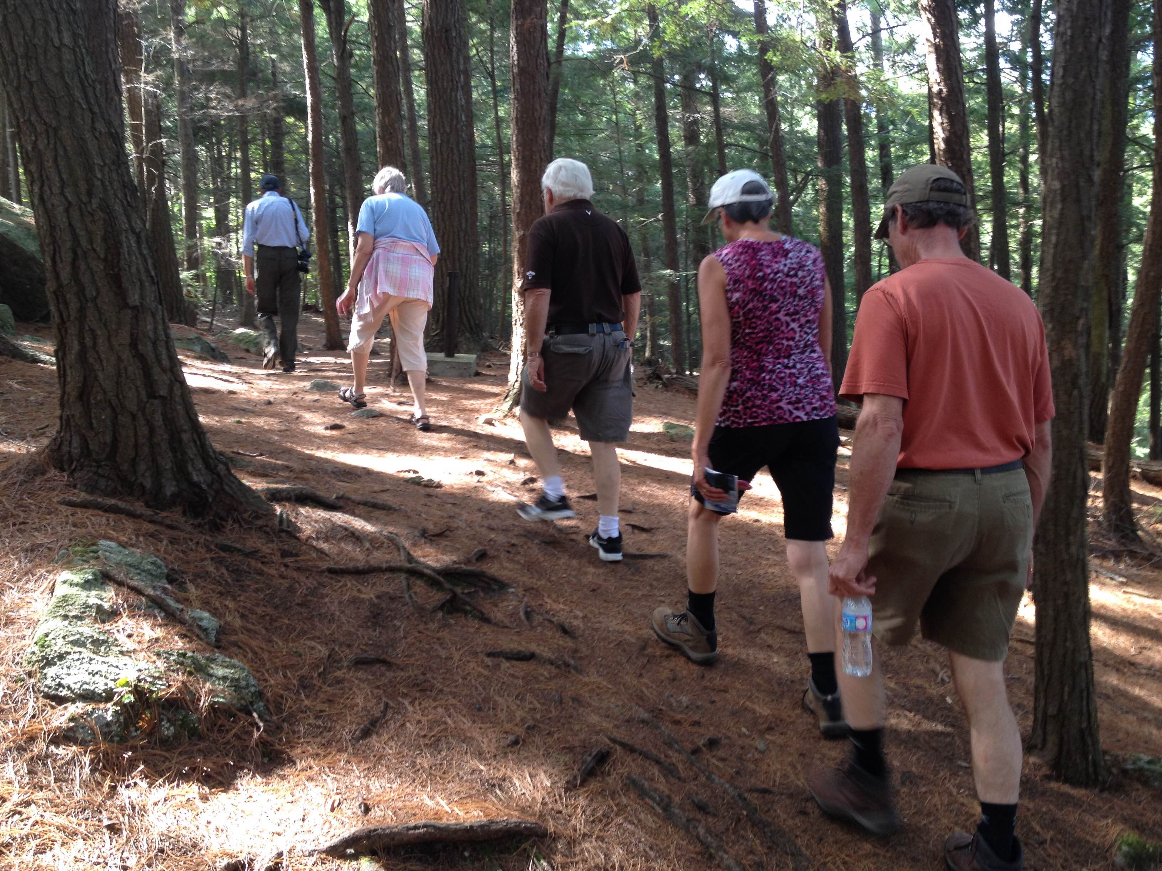
Space is limited! Register early!
www.leeds1000islands.ca

We
invite local Seniors to join us for a tour of the park followed by a light lunch.

Seniors Picnic
For more information:
Mary Jo Sibbald 613-929-3620

To Register:
Trish Cowan 613-659-2415 ext.227

Or email
seniors@townshipleeds.on.ca

  - at Charleston Lake Provincial Park

  - Thursday September 26, 2019
  - 10 a.m. to 1 p.m.

Transportation is provided and there is no fee to participate!

Accessible busing available from Wheels of Care upon request.
Bus Schedule |  | Pick Up Time | Return Time
Bus 1 | Seeley’s Bay Retirement Home | 9:30 a.m. | 2:00 p.m.
 | Lyndhurst Library | 9:45 a.m. | 1:45 p.m.
Bus 2 | Fox Run by the River | 9:20 a.m. | 2:00 p.m.
 | Lansdowne Community Hall | 9:45 a.m. | 1:45 p.m.
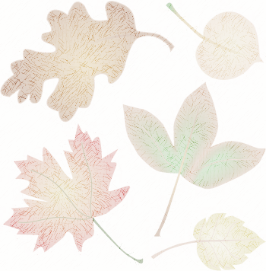
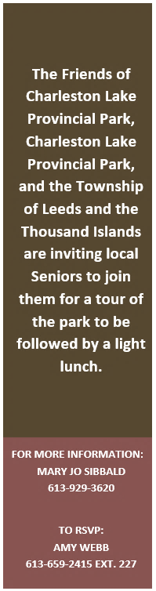
Space is limited!

Register early!

www.leeds1000islands.ca

