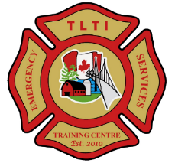
TLTI EMERGENCY SERVICES TRAINING CENTRE
312 Lyndhurst Road Lyndhurst, ON K0E 1N0

Course: Skills & Tactics: Positive Pressure Attack
Date: Saturday October 20, 2018
Time: 08:30 – 16:00 hrs
Class size: 12 (maximum)
Fee: $125.00 per student
Course Description:
The fire environment is changing. Over the past 50 years homes and their contents have changed and therefore so has the speed in which fires grow and spread. Positive Pressure Attack (PPA) introduces a science-based approach with proven results from new research conducted by Underwriters Laboratories (UL), National Institute of Standards and Technology (NIST), Fire Department of New York (FDNY), Toronto Fire Services and the National Research Council Canada.
This (1) day course will offer an introductory knowledge level to firefighters of all levels of experience, Officers and Chiefs a new perspective to changes that are taking place in the fire service. Crews will receive theory discussions and live-fire practice to demonstrate this technique in a controlled environment.
Student-Learners will require full structural PPE and breathing apparatus. Lunch will be included in course fee. Student-Learner’s will receive a certificate of participation.
For further information please contact:
Alex Bennett
Chief Fire Prevention Officer
Leeds 1000 Islands Fire Service

Cell: (613) 250-2300
alex@townshipleeds.on.ca

